Utah Juniper: Phase 2 Control

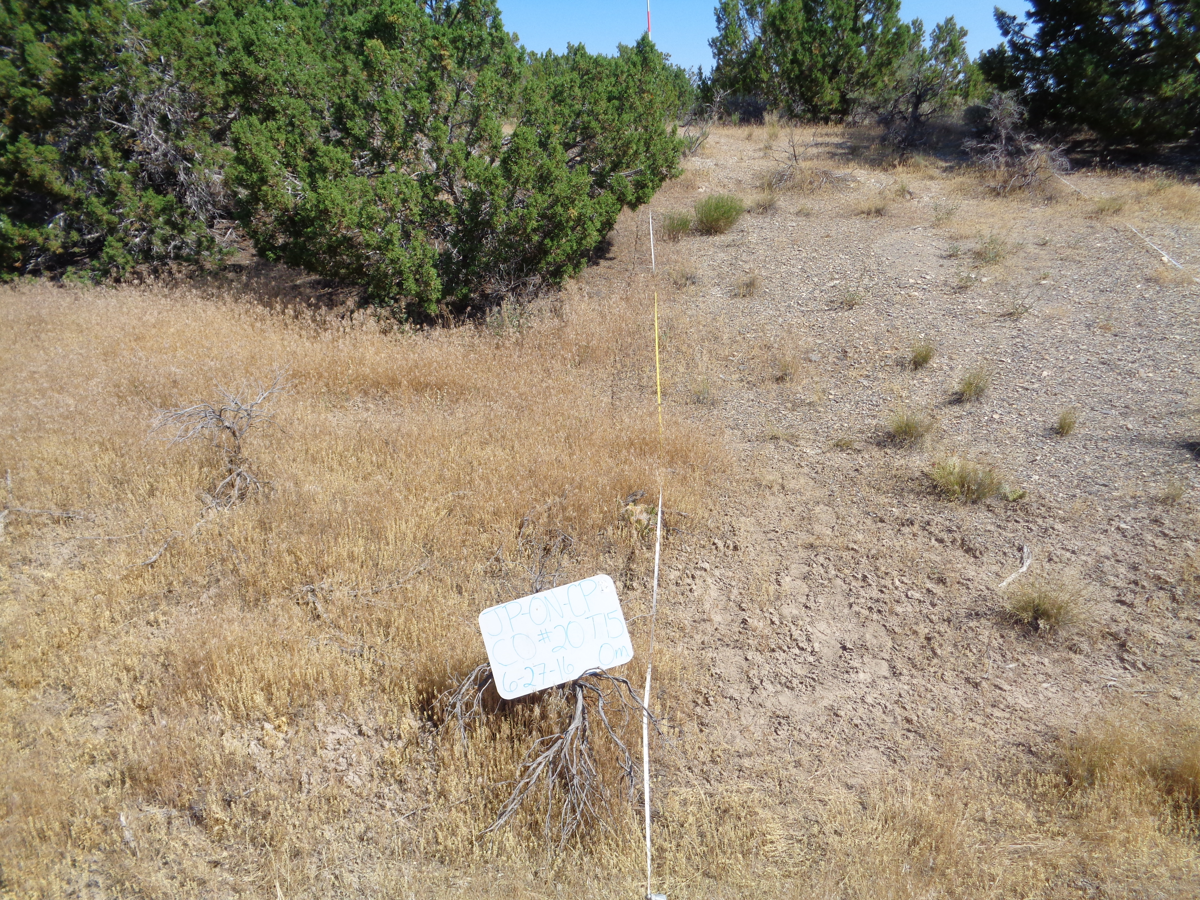

|  |  |
| --- | --- |
| Greenville Bench | |
| 5919 ft (1808 m) | |
| 7/27/2009 | |
|  | |
| Cover (%) | |
| Trees | 17 |
| Shrubs | 5 |
| P. Grass | 1 |
| A. Grass | 1 |
| Bare Ground | 60 |

|  |  |
| --- | --- |
| Greenville Bench | |
| 5919 ft (1808 m) | |
| 7/27/2009 | |
|  | |
| Cover (%) | |
| Trees | 17 |
| Shrubs | 5 |
| P. Grass | 1 |
| A. Grass | 1 |
| Bare Ground | 60 |

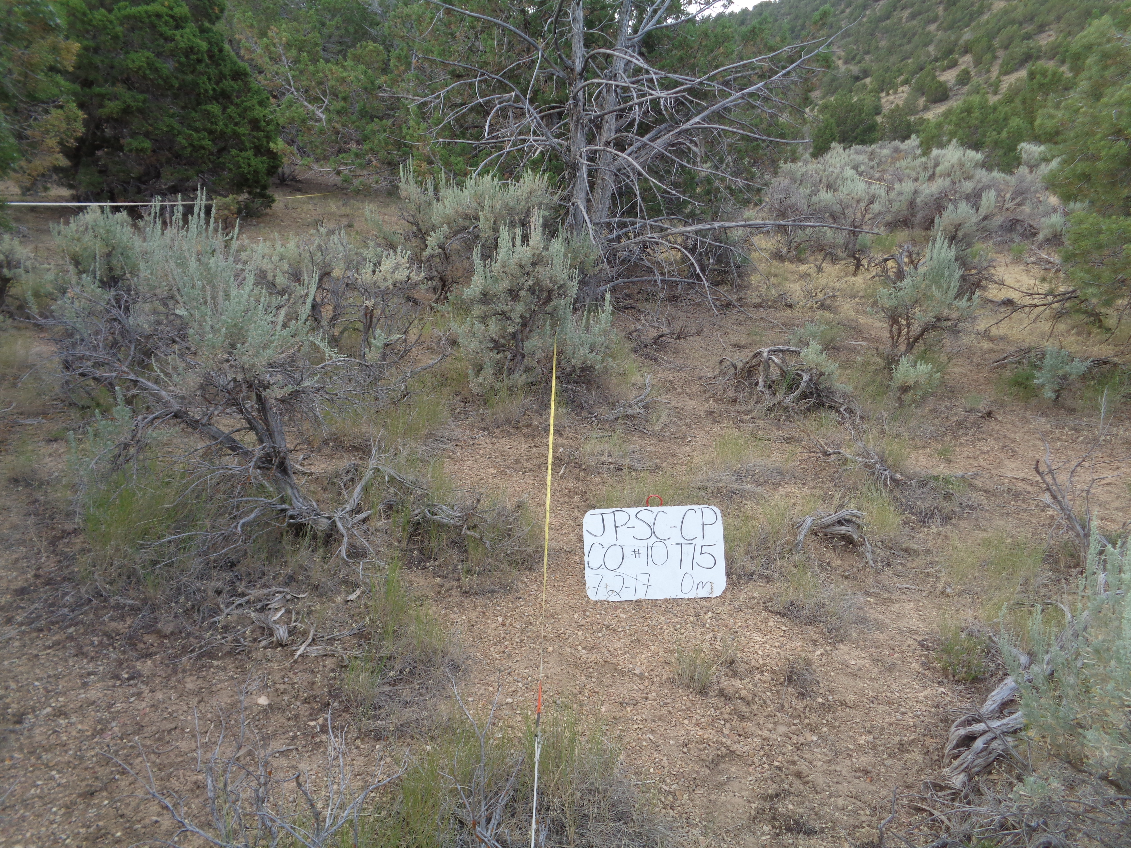

Utah Juniper: Phase 2 Control

|  |  |  |  |  |  |
| --- | --- | --- | --- | --- | --- |
| **Variable** | **Category** | **Component** | **Min** | **Mean** | **Max** |
| **Total Cover (%)** | Trees | JUOS | 7 | 18 | 34 |
| PIED | 0 | 5 | 22 |
| Shrubs | ARTRW8 | 1 | 8 | 21 |
| CHVI8 | 0 | 1 | 6 |
| PUST | 0 | 0 | 0 |
| Herbaceous | Perennial Grass | 3 | 14 | 24 |
| Annual Grass | <1 | 5 | 33 |
| Forb | 1 | 20 | 39 |
| Litter & Duff | Interspace Litter | 31 | 49 | 64 |
| Bare Ground | Bare Ground | 56 | 72 | 85 |
| **Density (#/acre)** | Trees | JUOS | 37 | 126 | 311 |
| PIED | 0 | 60 | 276 |
| Shrubs | ARTRW8 | 318 | 1373 | 2453 |
| CHVI8 | 0 | 670 | 3883 |
| PUST | 0 | 0 | 0 |
| **Height (in)** | Shrubs | ARTW8 | 8 | 20 | 36 |
| CHVI8 | 0 | 4 | 12 |
| PUST | 0 | 0 | 0 |
| Herbaceous | Grass | 2 | 7 | 12 |
| Forb | 1 | 3 | 6 |
| **Fuel Loading (tons/acre)** | Shrubs | ARTRW8 | 0 | 0.73 | 2.84 |
| CHVI8 | 0 | 0.00 | 0.05 |
| PUST | 0 | 0 | 0 |
| Herbaceous | Live | 0.01 | 0.07 | 0.18 |
| Dead | 0 | 0.02 | 0.25 |
| Downed Woody Debris | 10-hr | 0.10 | 0.31 | 0.70 |
| 100-hr | 0.10 | 0.56 | 1.28 |
| 1000-hr sound | 0 | 0.16 | 0.57 |
| 1000-hr rotten | 0 | 0.06 | 0.26 |
| Litter & Duff | Interspace Litter | 0 | 0.24 | 0.87 |
| Tree Litter + Duff | 3.44 | 7.90 | 19.31 |
| **Bulk Density (lbs/ft3)** | Shrubs | ARTRW8 | 0 | 0.0143 | 0.0401 |
| CHVI8 | 0 | 0.0001 | 0.0017 |
| PUST | 0 | 0 | 0 |
| Herbaceous | Live + Dead | 0.0023 | 0.0108 | 0.0288 |